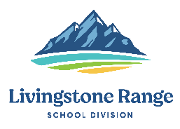
Livingstone Range School Division
Superintendent Report
2021-2022 School Year

Name, Position: Darryl Seguin, Superintendent
Board Meeting Date: November 23, 2021

Highlights

Functions & Meetings

- Board Advocacy meeting
- Board Committee of the Whole meeting
- Board Special Meeting
- Admin Council meeting
- 5 One on One meetings with school principals
- Inspiring Leadership Part 1 (evening session) and Part 2 (full day session)
- CCHS Staff Meeting

Professional Development
- ASBA Fall AGM
- Assessing Student Progress webinar (Dr. David Tranter)
- CASS Fall Conference
- LRSD Divisional PD Day

Key Areas for Next Month

- Board Committee of the Whole meeting
- Admin. Council meeting
- Regular Board Meeting
- Regional School Council Meeting
- TEBA Engagement Session
- MHHS Staff Meeting
- 1 on 1’s with school principals
- Team Collaboration meeting

